**BIKE SPARE INVENTORY MANAGEMENT SYSTEM**

**UML DIAGRAMS**

**ARCHITECTURE DIAGRAM**

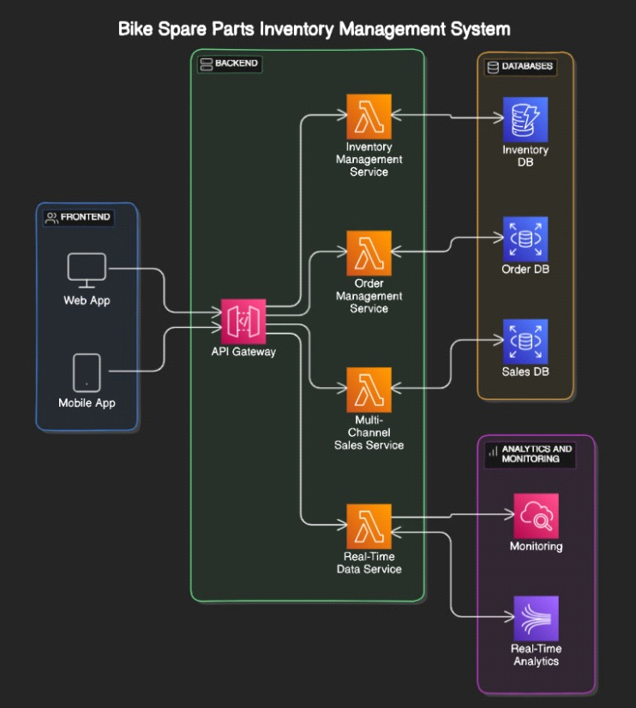

**CLASS DIAGRAM**

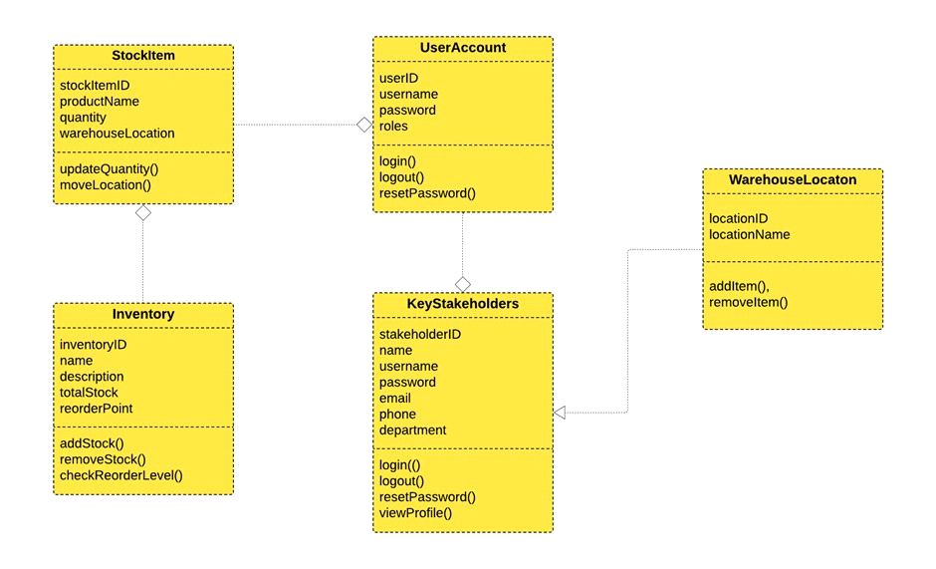

**SEQUENCE DIAGRAM**

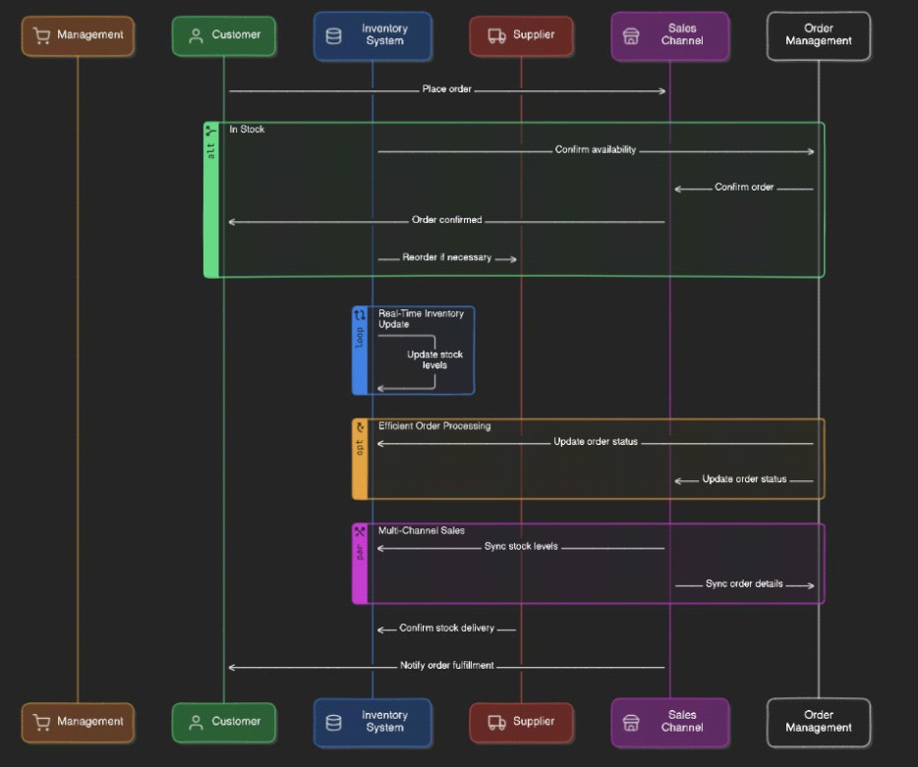

**DEPLOYMENT ARCHITECTURE**

